**Quiz on Module 2 -3 – Full blast3**

Name:………………………………………………..class …………………..

**-Write the correct words under each picture**

|  |  |  |  |
| --- | --- | --- | --- |
| goggle | baboon | zebra | stick |

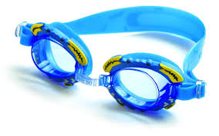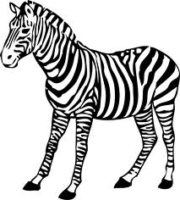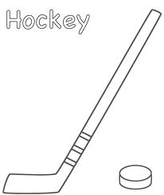

………………………………. ………………………. …………………….. ………………….. ________________________________________________________________________________________

**A- Match the words with their pictures.**

{ fever – cucumber- sore throat – stomachache – lettuce – headache – cough –).

stomachache.jpg 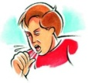 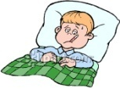 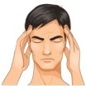  

(1)…………………(.2)…………………….(.3)…………………………(.4)…………………………(5)………………………(6)…………………………..

________________________________________________________________________________________

**B- Choose the correct words:**

1- can you ( smiley – text ) Peter about tomorrow's trip ? .

2- I sometimes send my parents ( type – text messages ) but they can't read chat speak.

________________________________________________________________________________________

**A-Choose the correct words**:

1- My mobile phone is ( too old –old enough ). I need to buy a new one.

2- ( How much – How many ) sugar do you put in your coffee?

3-- We ( have – has ) done our homework.

4- She has ( go – went – gone ) to her friend's house.

5-- Have you ( ever – never ) visit London

**B- Write a sentence. Use *should or shouldn't*:**

1. Julie has got a headache. ( take / painkiller ) ……………………………………………………………………………………………
2. He should go to school. No. he…………………………………………………………………………………………………………

**1-Put the jobs in the correct group:**

( paramedic –cameraman – builder – lifeguard)

|  |  |  |  |  |
| --- | --- | --- | --- | --- |
| ………………………………………………….. | BRB | Emergency service | construction | Media |
| ……………………………………………………………… | ZZZZZZZ |  |  |  |

**MR : DHAFER AL FAWAZ**

|  |  |
| --- | --- |
| @ | 1……………. |
| THX | 2………….. |
| PLS | 3…………… |
| CU | 4………….. |

-------------

10