**Revision Unit 3**  3rd Grade secondary

**1- Choose the correct word under the picture :**

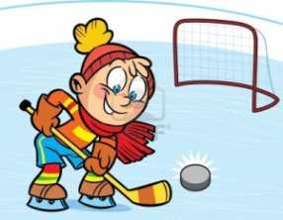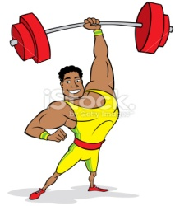



a-(boxing-judo) b-(swimming-sailing ) c-( gymnastics- weightlifting) d-( ice hockey – golf)

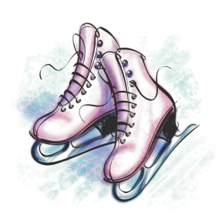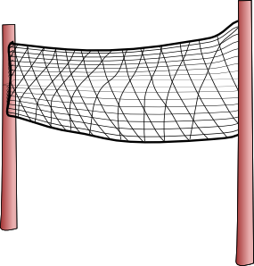

e-(skates-trainers ) f-( net- racket )

2-

**Defining relative clause :**

Foot ball is the sport **which he loves the most**

We use : which with things

who with people

where with places

when with times

whose with possessions

* we can use that instead of who and which

**Non defining relative clause :**

The king **, who was very big ,** loved playing tennis .

We put comma before and after the relative clause , and we can delet the clause without affecting the meaning .

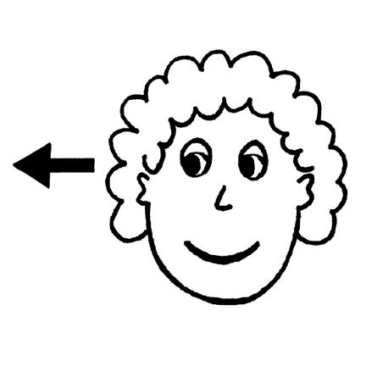

**a-Choose the correct answers :**

1- A football is a game **( which – who )** many people play

2- The people **( who – which )** watch sports events are called spectators

3- Ice hockey is the sport **( who – that )** is very popular in Canada

4- Brazil is the country **( which – where )** has won the fifa world cup most times

5- Alfanateer is the place **( where – which )** we spent our summer evenings there

6- 1420 is the year **( where – when )** my son travelled to America for studying

**b- Take out the relative clause ( if possible ) :**

1- Scotland , where golf began there , has lots of great golf courses.

---------------------------------------------------------------------------------------

2- The Sheraton hotel , where we stayed in the summer , was beautiful

---------------------------------------------------------------------------------------

3- The student who won the race is Ahmad Alghamdi.

---------------------------------------------------------------------------------------

**3- Give one example for the followings :**

a- martial art : -------------------------------------

b- winter sport : -----------------------------------

**4- Choose the correct answers :**

a- The place where you play football --------- **( pitch – rink )**

b- The place where you play basketball or tennis ------------ **(court – slope)**

**5- Complete the sentences with the correct *(phrasal verbs)* :**

a- I am going to ---------------------- tennis, Tomorrow I’m going to buy a racket .

b- They are really strong . They ---------------- in the gym, doing weightlifting .

**6- Write a simple essay about your favorite sport , how many players does it need , where it can take place , How to play it , what is your favorite team and you favorite player and little bit information about him /her :**

------------------------------------------------------------------------------------------------------------------------------------------------------------------------------------------------------------------------------------------------------------------------------------------------------------------------------------------------------------------------------------------------------------------------------------------------------------------------------------------------------------------------------------------------------------------------------------------------------------------------------------------------------------------------------------------------------------------------------------------------------------------------------------------------------------------------------------------------------------------------------------------------------------------------------------------------------------------------------------------------------------------------------------------------------------------------------------------------------------------------------------------------------------------------------------------------------------------------------------------------------------------------------------------------------------------------------------------------------------------------------------------------------------------------------------------------------------------------------------------------------------------------------------------------------------------------------------------------------------------------------------------------------------------------------------------------------------------------------------------------------------------------------------------------------------------------------------------------------------------------------------------------------------------------------------------------------------------------------------------------------------------------

Prepared by

Teacher..Bushra Assiri