**Revision Unit 1.. Learning for life** 3rd Grade Secondary

**1- Choose the correct words under the pictures :**

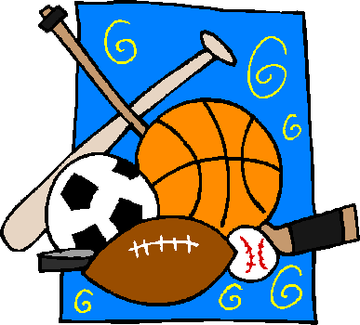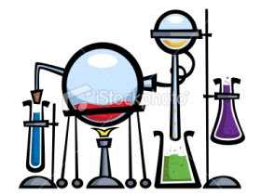

a-( chemistry – biology ) b-( media studies – medicine ) c-( physical education – physics )

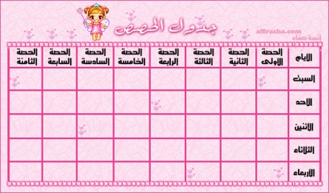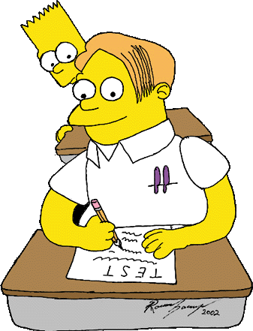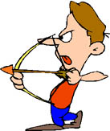

d-(archery – kayaking ) e- ( cheat – fail ) e- (certificate – timetable )

**2- Underline the odd word :**

a- grade – mark – resit – result

b- essay – exam – term – test

c- geography – history – maths – timetable

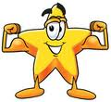

3-

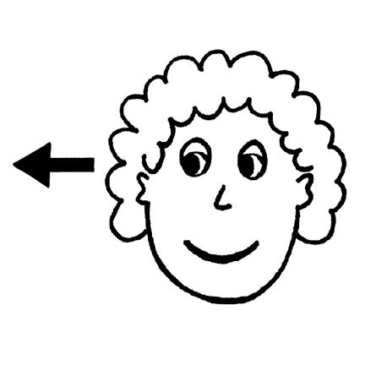

**Modals verbs for** : **obligation** : have to must

**No obligation** : don’t have to

**Permission** : can

**Prohibition + no permission** : mustn’t – can’t

**Advice** : should – ought to- had better

**Fill in the spaces with the following :**

( have to – don’t have to – must – mustn’t)

a- You ------------------------------------------------ do the extra exam , its optional.

b- you ----------------------------------------- use mobile phones in the class.

c- you ---------------------------------------- pray everyday.

d- Students ------------------------------------- wear a school uniform in America.

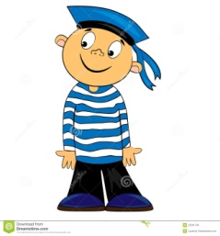4- Add the correct suffix:



a-Photograph ----------------- b-sail ----------------- c- teach -----------------

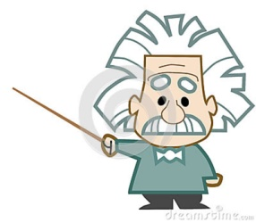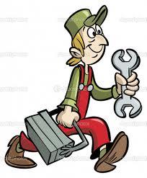

d- paint ---------------- e- technic ------------------ f- physic----------------------

5-

**First conditionals second conditionals**

Possible imaginary

If + present simple , will/won’t+ infinive If+ past simple , would/wouldn’t + infinitive

If Samar comes , I will be happy If I travelled yesterday . I wouldn’t attend the lecture

**Correct the verb :**

a- If I had time , I --------------- **(will )** join the team

b- If there are free Italian classes , she ------------------------- **( learn )** Italian .

c- If we --------------- **( arrive )** late today , the teacher will ----------------- **( got )** angry

d- If I became famous , I -------------------- **( will try )** to be good example for young people.

**6- Match the words with their definitions :**

a- The theories of Isaac Newton - academic

b- a country legal system - resit

c- relating to education especially in college and university - physics

d- takes a long time to do - law

e- to do it again - time-consuming

prepared by

Teacher : Bushra Assiri