Module 3

Going places

**A ) but you need to be physically fit .**

**B ) I used to take part in swimming races at school**

**C ) just bring your swimsuit.**

**D ) What equipment do we need ?**

**E ) Are we allowed to go exploring alone ?**

1 - Complete the dialogue with phrases:

Pete : Do you want go scuba-diving with me at the weekend ?

Jake : sure ………………………………………………………………………………….

Pete :Nothing .The instructors gives you everything you need.

Jake : O.K

Pete : ……………………………………………….you are , right ?You're a swimmer.

Jake: Of course …………………………………………………………………………………

Pete: Excellent .

Jake :……………………………………………………………………………………..

Pete: Not the first time you go. But after you get some experience , of course .

Jake : Anything else I need ?

Pete:…………………………………………………………………………………….

*2-* **Fill in the spaces with the correct answer :**

**Tour - coast – peaceful - passengers**

1 – There were only fifty …………………...on the plane .

2 – we went on ………………….of the city .

3 – Abdulaziz lives in a …………………area. It's nice and quiet .

3 – Match the words in column ( A ) with ( B )

1 – waterproof ( ) the smallest possible.

2 – beginners ( ) going straight up or down.

3 – cosy ( ) comfortable and warm .

4 – vertical ( ) not letting water in .

( ) people starting to learn.

4 – Choose the correct meaning of these words :

1 –spectacular { important – shapes - impressive }

2 – ancient { quiet – very old – not dangerous } .

3 – thrill { arrival - excitement – surely }

5- Put the correct word under picture :

**Coast - museum - volcano - mountain range**

[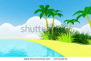](https://www.google.com.sa/url?q=http://www.shutterstock.com/pic-107510834/stock-photo-cute-tropical-coast-in-bright-cartoon-style-the-sea-and-clouds-d-image.html&sa=U&ei=J0s_U6PlFJCrhQeUxICABw&ved=0CCwQ9QEwAA&usg=AFQjCNHOeDqZ7obK-Q68GpSHHevmx_O2pA)

**[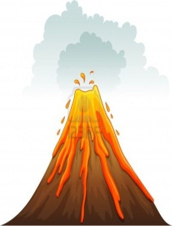](http://us.123rf.com/400wm/400/400/iimages/iimages1205/iimages120500448/13593729-illustration-of-a-volcano-erupting.jpg)**

[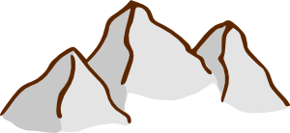](javascript:edit(6461))

…………………… ………………………………….. ………………………

6 – Cross out the odd words :

Cliff - valley - jungle - house - waterfall

Boarding card - flight attendant - conveyor belt - shower – passport

Grammar

1 - Do as shown between brackets :

1 – be physically / have / you / fit / to . {{ arrange }}

……………………………………………………………………

2 – use / your / mobile ? {{ Make requests }}

……………………………………………………………………………

3 – The plane is safe than train . {{ correct Mistake }}

……………………………………………………………………………………….

2 – Choose correct answer :

1 – The royal hotel is { most expensive – expensive – more expensive } than central hotel .

2 – I think Mr . Nasser is the { good – best – better } teacher in our school.

3 – Jone is the { older – old oldest } boy in his class.

4 – The Yangtze isn't as { longer – long – longest } the amazon.

3 – Form indirect questions :

1 – Where is the swimming pool ?

Do you know …………………………………………………………………

2 – Where did you stay ?

Can……………………………………………………………………………

3 – What time does the gym open ?

………………………………………………………………………………………….